**1. Creating a new Note using POST /notes API or Similar.**

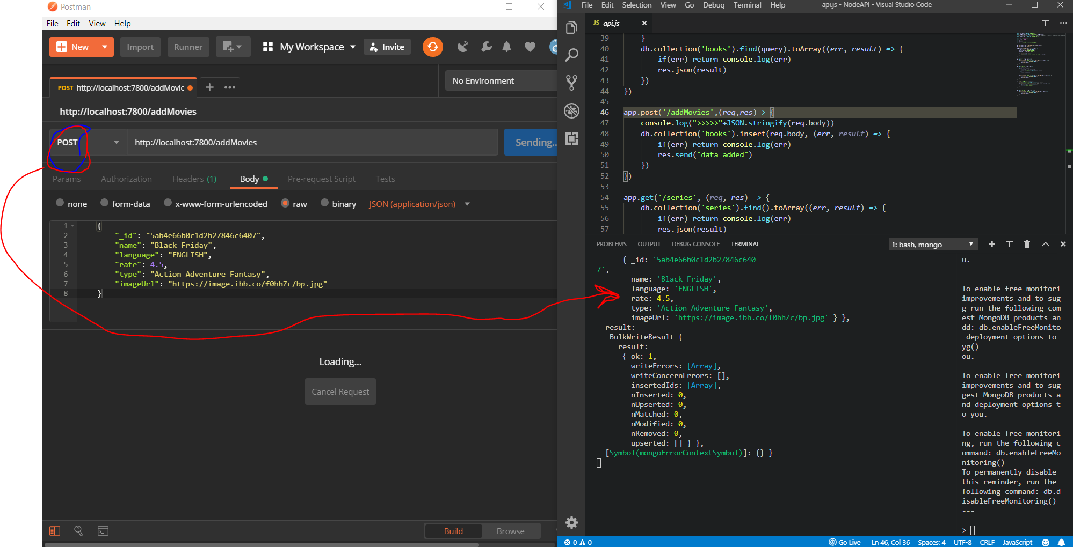

**2. Retrieving all Notes using GET /notes API or Similar.**

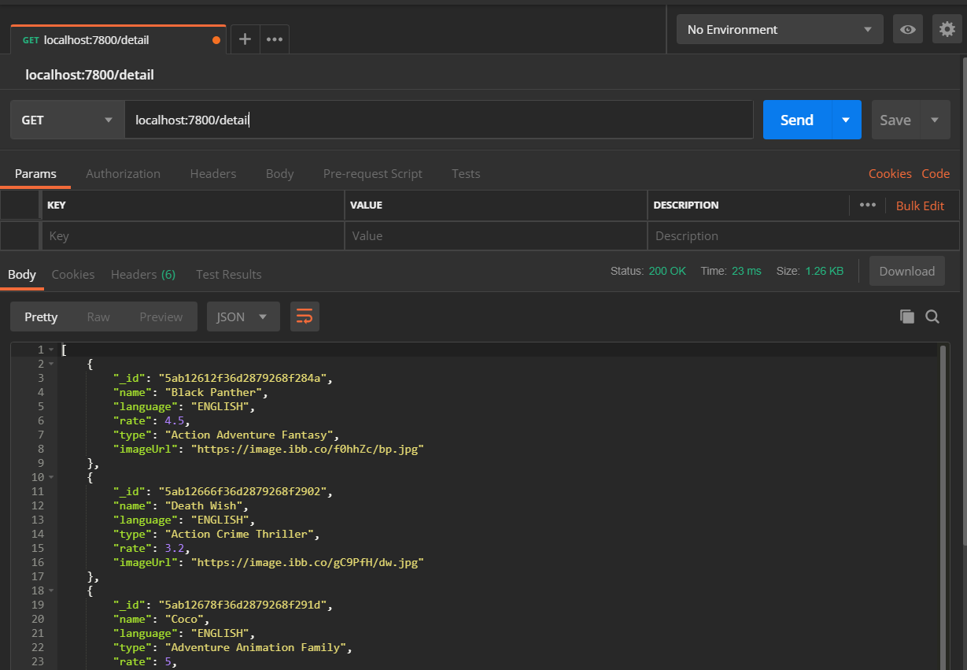

**3. Retrieving a single Note using GET /notes/:noteId API or Similar.**

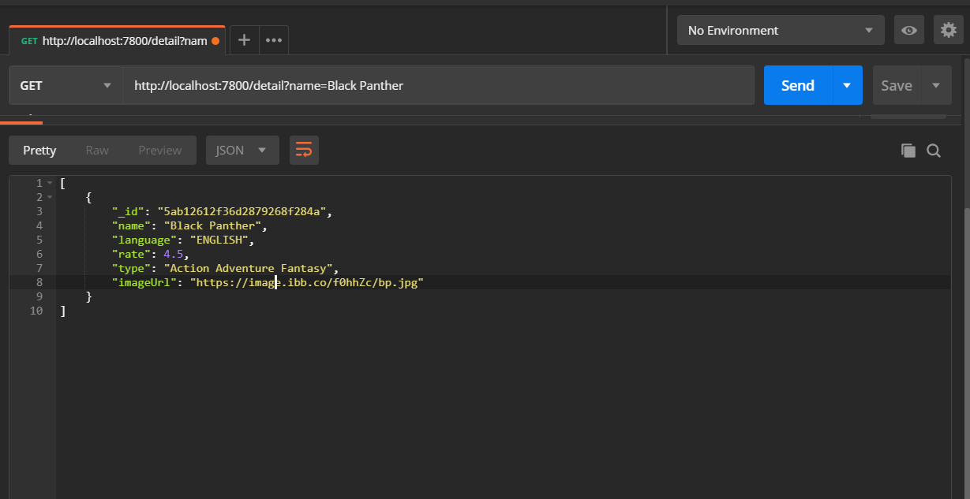

**4. Updating a Note using PUT /notes/:noteId API or Similar.**

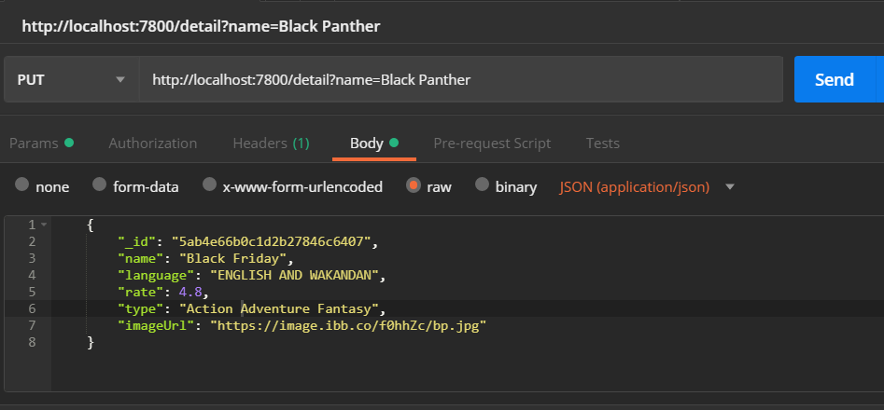

**5. Deleting a Note using DELETE /notes/:noteId API.**

